Day 5:

Q.1 Debugging

Create a yaml that will install a httpd package variable value that is stored in playbok of package name

Variable var1 -- value – httpd

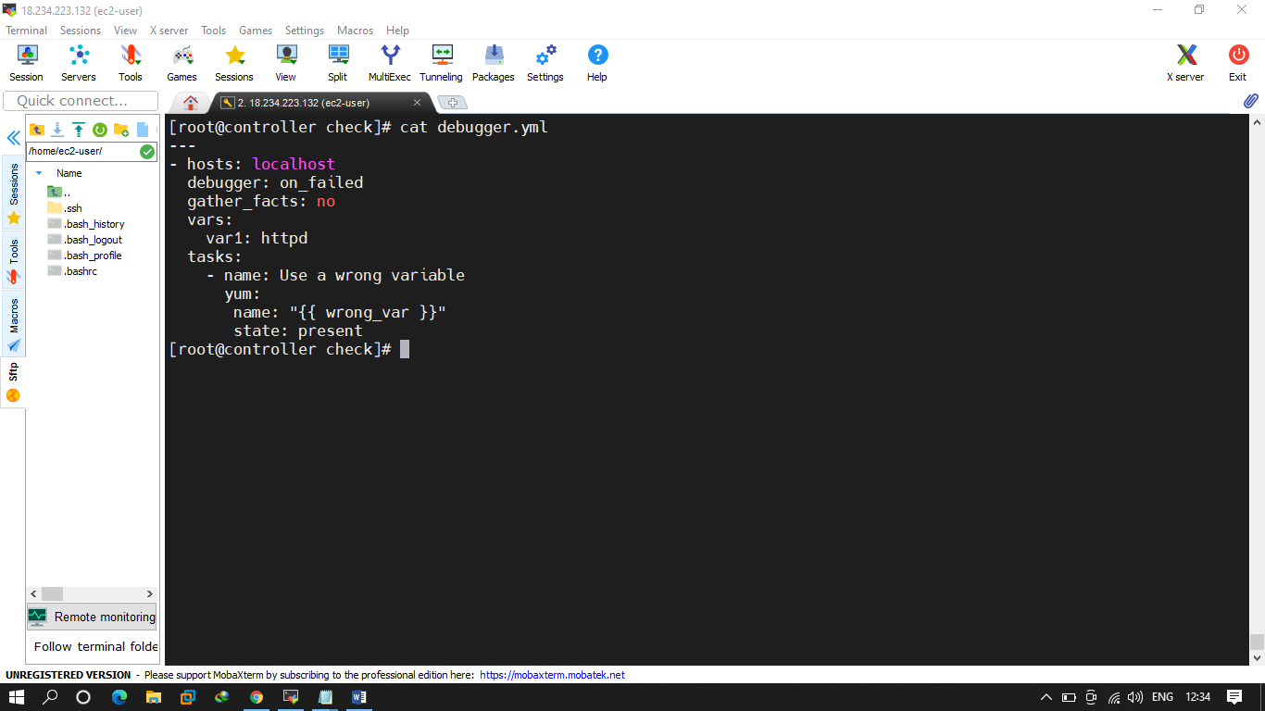

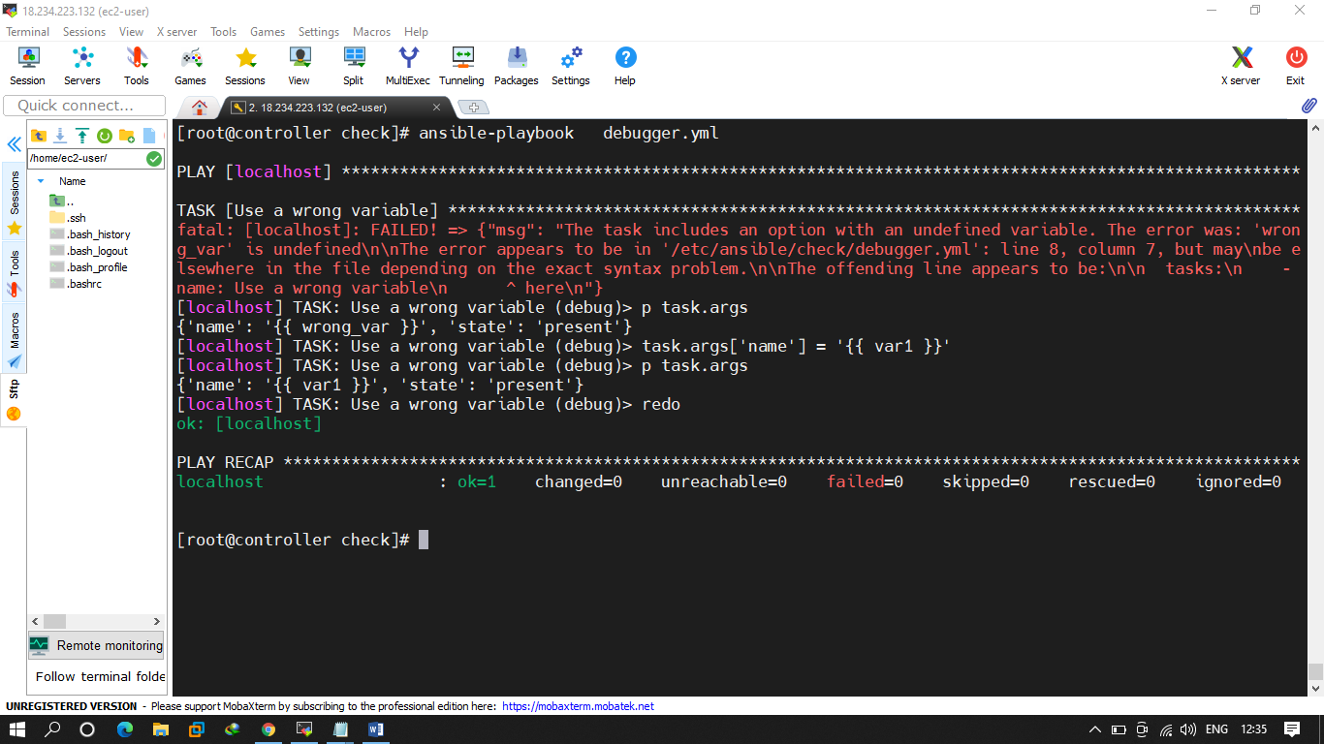

Q.2

try to reboot the server using correct time. using asychrnous and polling.

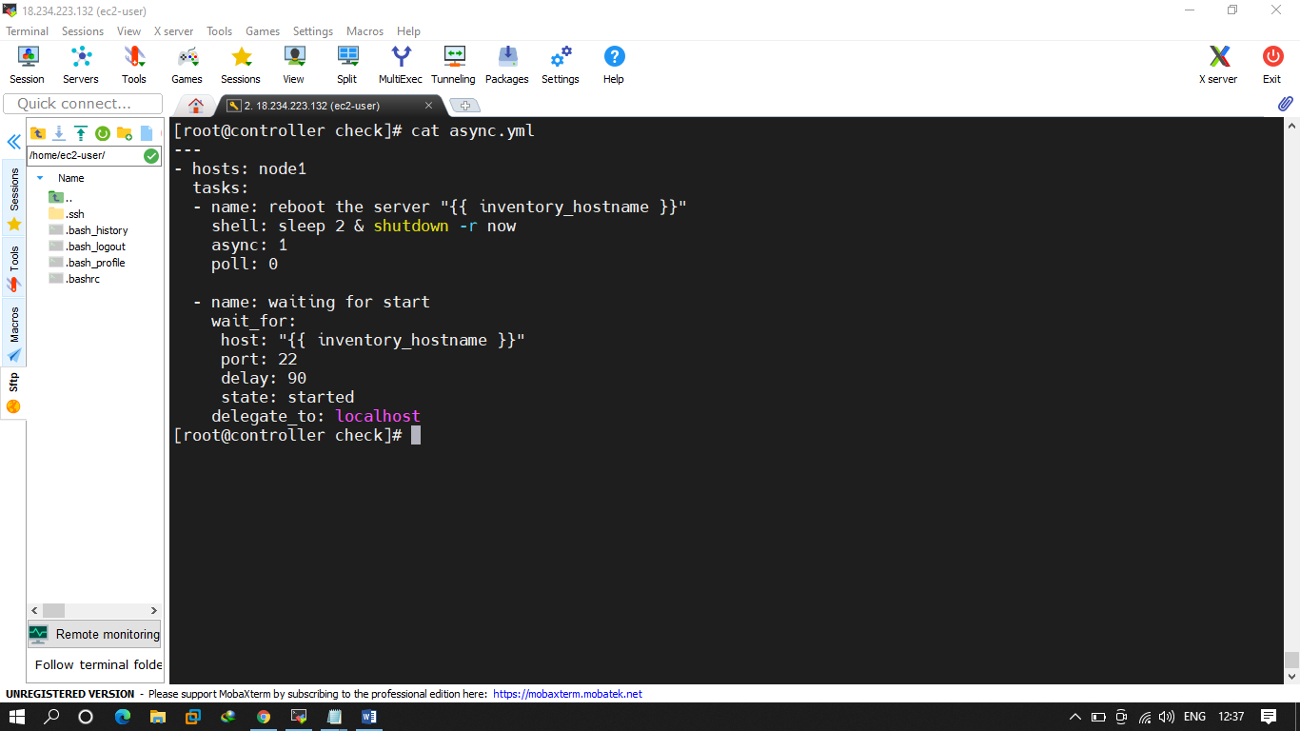

Q.3

Flow control -- Create any playbook in that try to use cond. , variables , tags.

